**Frame**

For the frame two principals were looked at, force distribution and centre of mass. For force distribution both wheel and seat placements were examined. For centre of mass the height of the seat from the ground was researched.

**Force distribution** is how the weight of the bike, outer shell, and interior components affect the bike, mainly in sturdiness and handling.

**Wheel placement** is determined by the length of the wheelbase which is measured from the centre of the rear tire to the centre of the front tire a long wheel base between 165-180cm, will provide a comfortable ride but will be less sturdy and have a decrease in handling. A short wheel base is between 83cm and 114cm, this will cause the driver to be more uncomfortable since he is right on top of the front wheels, but we make the bike much sturdier, and turning and handling are much sharper. A compact long wheel base is the best of both long and short, it is comfortable, sturdy, and great steering. We have decided to go with the compact long which is between 114cm and 165cm. for the design we are going with 120cm in length best on the other dimensions.

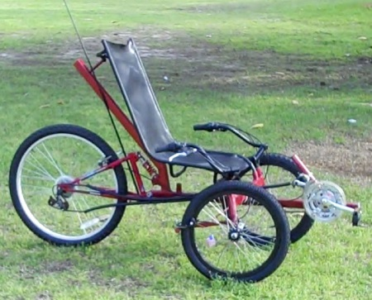

This figure shows a bike with a very

short wheel base, which is not ideal.

The **seat placement** determines how comfortable and sturdy the bike it. If the seat is too close to the rear tire the bike could flip backwards and would be less sturdy. Also is the seat if too close to the front tires the bike could flip forward, but if very unlikely to tip, but the ride may be more uncomfortable. So a ratio of 70/30 (closer to the front tires) was chosen to provide both comfort and sturdiness. With a 120cm wheel base, the seat will be placed 84cm from the rear tire. This is the ideal placement; it is the starting point and can change in order to move the seat to tailor to each individual.

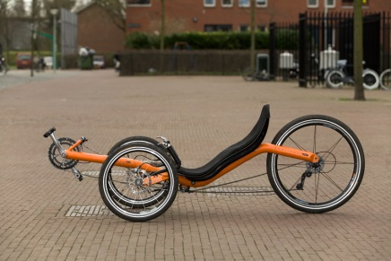

This figure shows a bike with close to an ideal seat placement.

The centre of mass is a single point that has an evenly dispersed mass in every direction.

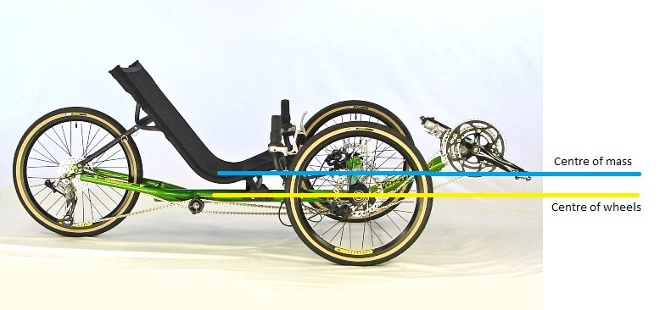

For **centre of mass** I am looking at how high the seat it from the ground. A seat that is too high will cause the bike to become unstable and may tip over easily. A seat that is too low will ensure the bike never tips, but the driver will have a lack of visibility which will cause other safety issues. Since the wheel and seat placement are in ideal locations the seat will be as high as the centre of the wheels. This will be achieved by bending the frame in order to allow space for seat suspension. The frame will be lowered about 13cm so the centre of mass is either equal to or lower than the centre of the wheels.